AML Transaction & Fraud Analysis – Business Insight Report

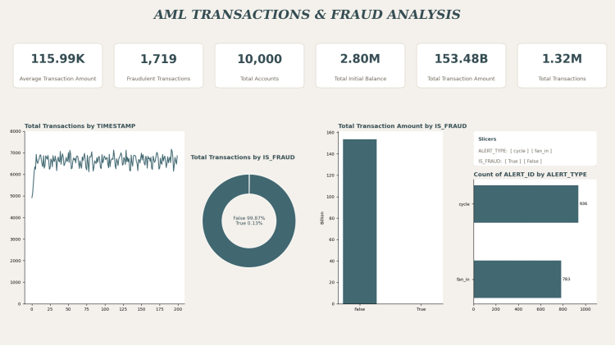

The dashboard presents AML transactions, fraud status, transaction activity over time and alert types through KPI cards, a pie (donut) chart, a bar chart, a line chart and a horizontal bar chart, supported by interactive filters. Together, these elements help identify activity that may be suspicious and may require further review.

2. Overview of the AML Dataset
The dataset contains three related tables: accounts (10,000 accounts), transactions (approximately 1.32 million transfer records) and alerts (records linked to transactions that triggered an AML alert). The purpose of the analysis is to summarise transaction volume, value, classification status and alert patterns so that activity indicating possible risk can be identified and prioritised for review.
The key fields used in the dashboard are IS_FRAUD (the classification flag for a transaction or account), TIMESTAMP (the time step of each transaction, used for trend analysis), ALERT_ID (the identifier linking transactions to an alert) and ALERT_TYPE (the alert category, such as cycle or fan_in).

3. KPI Interpretation
KPI | Dashboard Value | Interpretation
Fraudulent Transactions | 1,719 | Indicates the number of transactions classified as fraudulent (IS_FRAUD = True). These records may require investigation and should be reviewed before any conclusion is drawn.
Total Transaction Amount | 153.48 billion | Indicates the aggregate value of all transactions in the dataset and the scale of funds that monitoring controls must cover.
Total Transactions | 1.32 million | Indicates a high transaction volume, which requires automated and scalable monitoring.
Total Accounts | 10,000 | Indicates the number of distinct accounts represented; activity may be reviewed at account level.
Average Transaction Amount | 115.99K | Indicates the mean value per transaction; averages may mask outliers and should be reviewed alongside the distribution.

In summary, the KPIs indicate a very large transaction base and a high aggregate value, within which a comparatively small number of transactions are classified as fraudulent. These figures help size the monitoring workload but do not, by themselves, establish wrongdoing.

4. Fraud Status Analysis
The pie (donut) chart, based on IS_FRAUD, shows that transactions classified as False represent approximately 99.87% of the total, while those classified as True represent approximately 0.13%. The bar chart of total transaction amount by IS_FRAUD shows that the False category accounts for almost the entire transaction value, while the True column is very small by comparison and may be barely visible at this scale.
Insight: A low percentage does not mean low risk. Even a small share of transactions classified as fraudulent may require investigation, because concentrated or coordinated activity can have a disproportionate compliance impact.

5. Transaction Activity Analysis
The line chart of total transactions by TIMESTAMP shows an initial increase at the start of the period, after which activity fluctuates around approximately 6,000 to 7,000 transactions per time step. No sustained upward or downward trend is evident after the initial rise.
Insight: Time-based analysis helps identify unusual patterns. Sudden spikes or drops relative to the typical range may indicate activity that should be reviewed.

6. Alert Analysis
The horizontal bar chart of ALERT_ID counts by ALERT_TYPE shows approximately 930 alerts for cycle and approximately 780 for fan_in. A cycle pattern describes funds moving through a sequence of accounts, which may indicate circular movement. A fan-in pattern describes funds from multiple sources converging into a single account, which may indicate aggregation of funds.
Insight: Both alert types need investigation, and neither is automatic proof of fraud. Note that the chart counts ALERT_ID values on transaction-level records, so the figures may reflect transactions linked to alerts rather than distinct alert cases; this should be verified.

7. Filter-Based Analysis
The dashboard provides two filters. The ALERT_TYPE filter (cycle, fan_in) isolates activity by alert category, and the IS_FRAUD filter (True, False) separates transactions by classification status. These filters make the dashboard more useful by allowing reviewers to focus on specific subsets. Results should be checked to confirm that all charts and KPI cards respond correctly to each filter, since inconsistent filtering could lead to misleading interpretation.

8. Key AML Insights
● A low proportion of transactions (approximately 0.13%) is classified as fraudulent, which may still require investigation.
● Large transaction volume (approximately 1.32 million) indicates the need for automated monitoring.
● Significant transaction value (approximately 153.48 billion) indicates substantial exposure should issues be confirmed.
● Cycle alerts appear more frequent than fan_in alerts, which may indicate where review effort should be prioritised.
● Transaction activity fluctuates within a band, so deviations from that band should be reviewed.
● Interactive analysis through filters supports more targeted investigation.
● Further verification of KPI calculations, aggregation settings and filter behaviour is necessary before formal use.

9. Recommendations
● Strengthen fraud monitoring by reviewing rules and thresholds applied to high-volume transaction flows.
● Investigate high-priority alerts, particularly cycle and fan_in patterns, using documented review procedures.
● Monitor transaction activity continuously to identify deviations from the typical range.
● Improve fraud detection models by incorporating feedback from reviewed alerts.
● Use risk-based investigation to allocate resources to the alerts and accounts that appear highest risk.
● Improve dashboard accuracy by verifying KPI calculations, aggregations and filter behaviour.
● Maintain proper records of alert reviews, decisions and supporting evidence for audit and regulatory purposes.
● Review false positives regularly to reduce unnecessary workload and refine alert criteria.

10. Conclusion
The dashboard indicates a large and valuable transaction base in which a small proportion of transactions are classified as fraudulent. Alert activity is split between cycle and fan_in patterns, with cycle alerts appearing more frequent, and transaction activity fluctuates around a relatively stable range after an initial increase.
The KPI cards and charts help prioritise review effort by showing scale, classification status, activity over time and alert types, while the filters allow more focused analysis. All values are based on the dashboard as supplied, and the underlying calculations and aggregation settings should be verified before the figures are used for formal reporting.
Dashboard alerts are indicators for investigation, not conclusive proof of money laundering or fraud. Transactions must be reviewed in line with institutional procedures before any conclusion is reached.

